TASK 1: TABLE WITHOUT TIMELINE

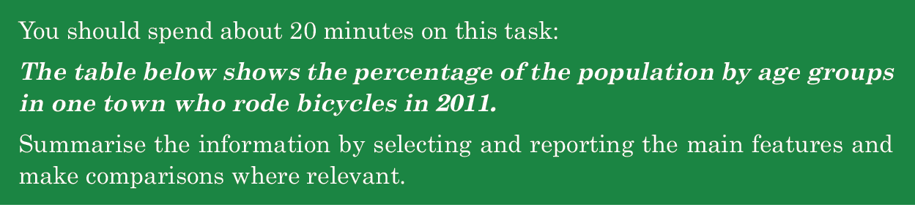

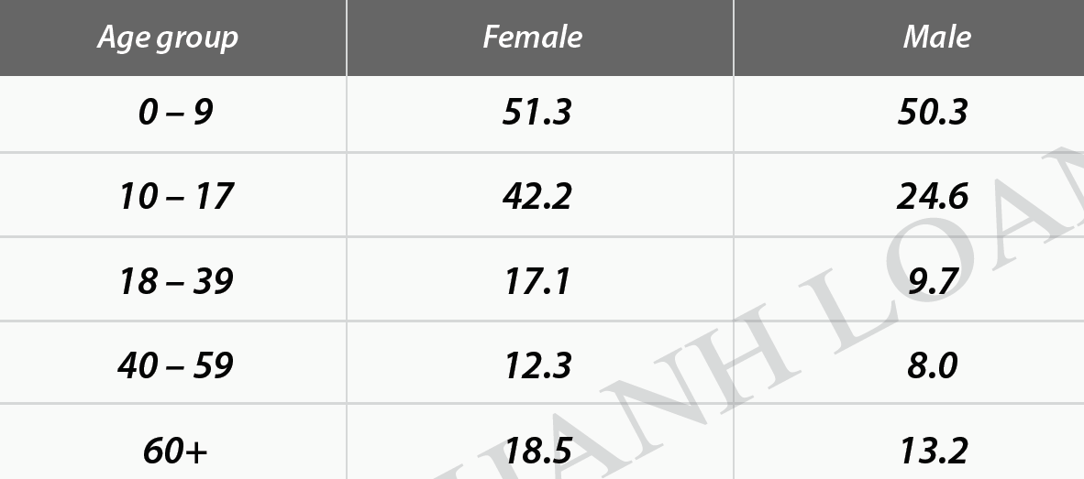
SAMPLE
The table provides data regarding the proportions of people in various age brackets of a town who pedaled in 2011.
Overall, the whole year of 2011 witnessed the lion’s share in the percentages of the youngest age group (0-9) using this means of transport, whereas the age group 40-59 held a rather minuscule share in the same field. Additionally, the numbers of females cycling every day surpassed those of males over the time.
As the chart reveals, under 9-year-old cyclists accounted for the largest proportion that year, with the figure for females outnumbering that of males, at 51.3% and 50.3% respectively. The disparity between the two genders was broadened when it comes to the 10-17 age group, with female figure almost double that of males.
However, as for the older age (18-39), the percentages of both genders in this town commuting by bike declined significantly, comprising a third of the 10-17 group’s figures. The two oldest groups (40-59 and 60+), on the other hand, bucked the trend somewhat in the numbers of bike riders. Female figures of these groups outperformed those of male, varying by more or less than 4.5%.

190

Outnumber/ surpass/ overshadow /overtake vượt trội

Respectively
In turn
Consecutively
orderly

Disparity=difference

Về mặt , đề cập đến
As for
In term of
Concerning
Relating to
Regarding
When it comes to

Ngược lai
In contrast,
However,
Meanwhile.
-----while, whereas, whilst-------
Conversely,
On the other hand,
Vary / alter/ oscillate from----to dao động trong khoảng
Between ----and
More or less than=around

======================

TASK 1: TABLE PRACTICE

You should spend about 20 minutes on this task.
The graph below shows the average retirement age of males and females in six countries in 2003.
Summarize the information by selecting and reporting the main features and make comparisons where relevant.
Write at least 150 words.

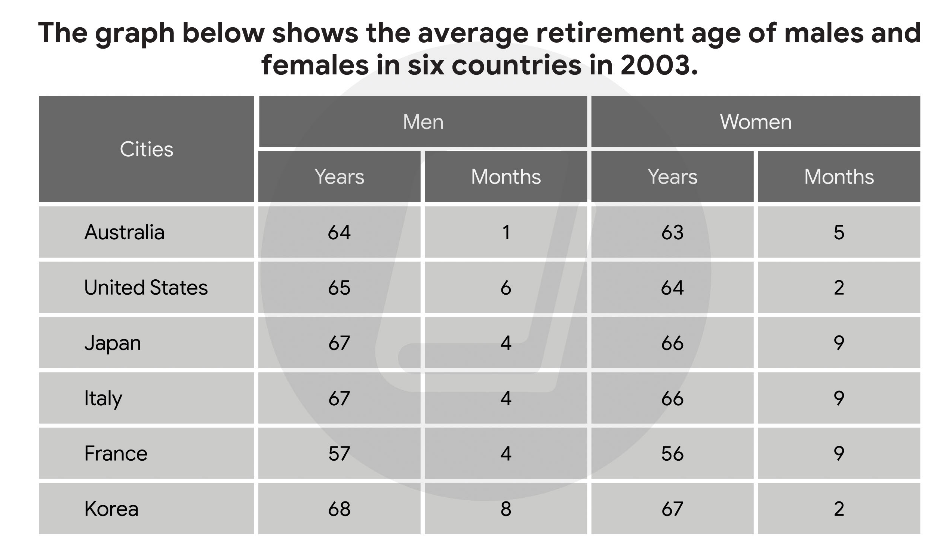

The provided table illustrates data regarding the usual retirement age of man/ men and women in six countries / six various in 2003.

Overall, Korea's / Korean ( uu tien cho tinh tu di voi danh tu, dung het moiduoc dung so huu cach ) average retirement age of men and women took the lion's share in the other five / in all countries. By contrast, France hold / held a rather minuscule share in the number of ordinary retirement age of both ca hai gioi tinh females and males / sexes. Additionally, males' retirement/ the number of males retirement age ( males laf tinh tu ) exceeded that / those of the other counterpart trong tat ca cac nuoc suot ca nam /among six countries the year.

As the chart reveals, Korea's working time of both females ( 68 years 8 months ) and males ( 67 years 2 months ) surpassed those others / those of the other . Whilst, the number of working years of man and women in France nguoc lai, nhung con so nay cua Phap dung o registered / By contrast, French number stood at ( while , whilts khong dung cham va phay chi co phay ) the bottom of the list with 57 years and 4 months for the former and 56 years and 9 months for the latter .

The number of working time of males and females in Japan and Italy , on the other hand, bucked the trend somewhat with both countries showing the same average retirement age with 67 years 4 months for men and 66 years 9 months for women. In addition, tiep theo sau la / Followed were ( folloby khong phay) Australian and American figures altering between roughtly 63 years and above 65 years.

figureUnited States's normal retirement age of man / men and women altered between around 63 years and above 65 years.

196
BAND SCORE: 4.5

